Case 5-A308-Asia-China-Majiabang Culture-Pendants-Two Hole-Jade- 5000-3900 BCE

 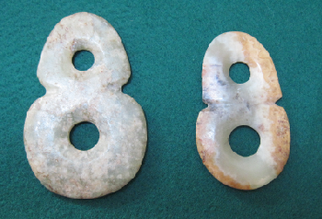

Case no.: 5

Accession Number: A408-A409

Formal Label: China- China-Majiabang Culture-Pendants-Two Hole-Jade- 5000-3900 BCE Display Description: This is a pair of large oblong two-hole-pendants from the Majiabang (Majiabin) Culture site of Xinchun Village in the South Lake area of the present-day city of Jiaxing, Similar examples are from Huating village, Northern Anhui, dated to 5000-3900 BCE. Here we experience a very early thin, lenticular oval shape with two holes similar to the conjoining of 2 two-dimensional tori, in a completely aniconic, geometric shape.

The Majiabang Culture developed this aniconic symbolic tradition which is related to the *iconic porcine torus tradition* of Hongshan so-called “pig-dragon” jade carvings from Liaoning (紅山-玉--豬頭龍--建平--遼寧).The Hongshan zoomorphic, figurines have pig-like snouts and pointed ears on an elongated, "suggestively fetal” or serpentine, limbless body, and were coiled around a central axis like a torus of revolution (see Childs-Johnson 1991). Early Hongshan pig-dragon jade carvings (ca 5000 BCE) have stout, pig-like bodies, while later Hongshan examples (ca 3000 BCE) have slender, serpentine bodies. Since these pig-dragon jade carvings have been excavated as Hongshan grave goods (Howard 2006), and since pig bones have accounted for 60 percent of animal bones recovered from Hongshan sites, it is inferred that pigs were important not only for the Hongshan economy but also for their symbolic significance. The melding of a fetal-serpentine shape with that of a pig may have been intended to couple an ancient dragon-serpentine shape with that of an economic icon producing a powerful Hongshan foundational image.

It is unknown why the Majiabang Culture developed this *aniconic symbolic tradition* which is related to the *iconic porcine torus tradition* of Hongshan so-called “pig-dragon.” Another example of this anconic torus tradition is the slit torus:



Majiabang slit jade torus.

LC Classification:

Date or Time Horizon: 5000-3900 BCE

Geographical Area: Lake Taihu area

Map:

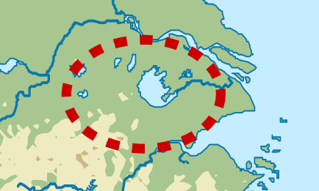

GPS coordinates:

Cultural Affiliation:

Media:

Dimensions:

Weight:

Condition:

Provenance:

Discussion:

      Majiabang Culture was a matriarchal society in the Taihu Lake area and was named after the Majiabang site in Jiaxing, Zhejiang, when it was first discovered in 1959 enclosing a ca 30-year-old human with a complete skull. Another Majiabang site was found in the lower stratum of the Songze site on the west side of the Fuquanshan site at Qingpu (Shanghai Qingpu Museum 2017).

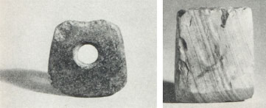

Stone axe of the Majiabang Culture, Stone adze of the Majiabang Culture

          From the lower stratum of the Songze site, some coiled, hand-made pottery vessels were excavated, including pottery Fu (cauldron), Dou(stem bowl) ox-nose shaped vessel’s ear and grate. Most of them are simple and coarse brownish red sandy pottery and a few reddish clay pottery with no decoration, made by coiling up the hand-molded clay strips.

       The Majiabang people used the local clay for their pottery vessels. The vessel Fu (cauldron) with a raised waist is its typical vessel. The Ding (tripod) appeared in its late period. There were also some pottery Pen (basin) and jar but very small in number.

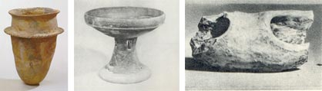

 Pottery Fu (cauldron) of the Majiabang Culture, Pottery Dou (stem bowl) of the Majiabang Culture, Ox-nose shaped vessel’s ear for stringing

       The earliest jade earring worn by the Shanghai women

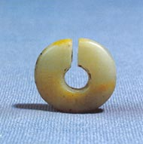

Jade Jue (slit-ring) of the Majiabang Culture

**Climatic fluctuations 4000-2200 BCE**: **development and demise of the Majiabang culture.**

Between 3678-3400 cal. BCE the climate was colder and drier than today. Then, from 3400- 2800 cal. BCE the climate was much warmer and wetter. Between 2800-2300 cal. BCE the climate was persistently cold, with an exceptionally cold event occurring between 2600-2300 cal. BCE. This cold event was recorded at several other localities in Northern China and in the Northern Hemisphere. It played an important role in the emigration of Inner Mongolian people from the Hunshandake Sandy Lands of Inner Mongolia (Yang et al. 2015) to immigrate to the Yangtze River delta and in turn they forced the Hongshan people to emigrate by 2200 BCE, a date that corresponds to the demise of the Hongshan culture which has been an enigma until now (Jin and Liu. 2002).



Map showing location of Hunshandake Sandy Lands outlined in black.

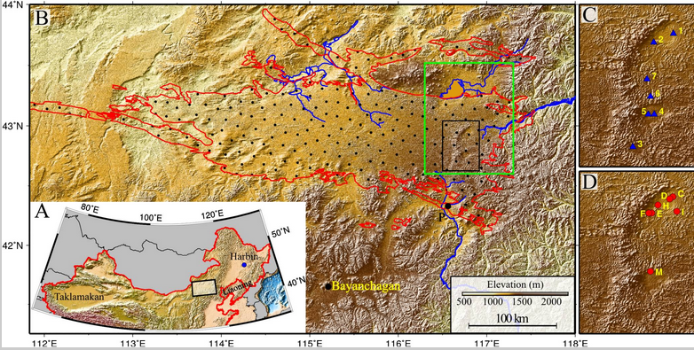

Geographical location of the Hunshandake Sandy Lands (A) and its area (encompassed by red line in B).

The black rectangle in B marks the location of the enlarged maps C and D on the Right, and the green rectangle shows the location of [Fig. 2](https://www.ncbi.nlm.nih.gov/pmc/articles/PMC4311860/figure/fig02/). Map C shows the localities of water samples, and map D shows the localities of stratigraphy The sand–paleosol section P ([Fig. 3](https://www.ncbi.nlm.nih.gov/pmc/articles/PMC4311860/figure/fig03/)) is on the southern margin, and the site Bayanchagan marks the coring site to sample the paleosols (Jiang et al. 2006). Rivers with headwaters in the Hunshandake likely formed by groundwater sapping are marked in blue. Drainages to the southwest and west are currently undergoing groundwater sapping, with substantial spring-driven flow found at the current river base level. From <https://www.ncbi.nlm.nih.gov/pmc/articles/PMC4311860/figure/fig01/>

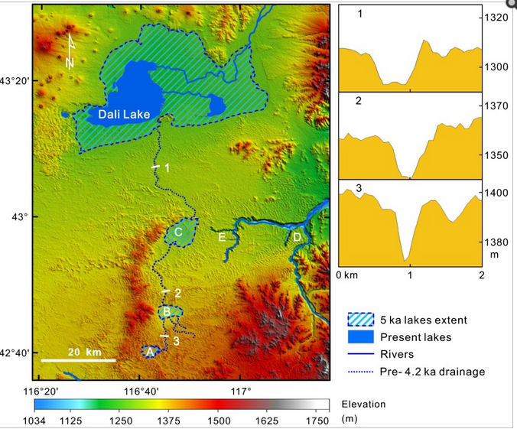

Map of the desiccation of Holocene lakes and channels in the Hunshandake Sandy Lands at selected epochs (Yang *et al*. 2015). Upper, middle, and lower lakes are indicated by points A, B, and C, respectively. Xilamulun River (point D) drains to the east. Groundwater-sapping headcuts at the upper reaches of incised canyons (point E) suggest a mid-Holocene interval of easterly surface flow, followed by groundwater drainage beginning at the ca. 4.2 ka event. Northern and central channels at point E are currently abandoned, and groundwater sapping has migrated to the southerly of the three channels shown. (Right) Cross-sections of the predrainage shift, northerly drainage into Dali Lake (Localities shown on the Left), showing the increase in widths of channels downstream (Vertical exaggeration ∼30:1).

**References**

Anderson, E. N., JR. I988. *The food of China.* New Haven: Yale University Press.

Blench, Roger. 2004. “Human migrations in continental East Asia and Taiwan: genetic, linguistic and archaeological evidence. Université de Genève” [DRAFT CIRCULATED FOR COMMENT]

Chang K. C. I977. *Food in Chinese culture*. New Haven: Yale University Press.

1986. 4th edition. *The archaeology of ancient China*. New Haven: Yale University Press.

1989. "Ancient China and its anthropological significance." In *Archaeological thought in America*. Edited by C. C. Lamberg-Karlovsky, pp. I 55-66. Cambridge: Cambridge University Press.

Childs-Johnson, Elizabeth (1991). "Jades of the Hongshan culture: the dragon and fertility cult worship," Arts asiatiques, **46**: 82–95.

Cohen, M. N., and G. J. Armelagos.1. *Paleopathology at the origins of agriculture*. Orlando: Academic Press.

Freid, M. H. I967. The evolution of political society. New York: Random House.

Freidman, J., and M. J. Rowlands. I978. "Notes towards an epigenetic model of 'civilization,"' in *The evolution of social system*. Edited by J. Friedman and M. Rowlands, pp. 20I-76. London: Duckworth.

Gao, G. I978. “Dawenkou culture its nature and chronology” (大汶口文化的性质和年代), *Kuangmingribao*, April 27.

Guo, Da-Shun 1995. Hongshan and related cultures. In: *The archaeology of Northeast China: beyond the Great Wall.* Nelson, Sarah M. ed. 21-64. London and New York: Routledge.

Guo D. *Hongshan Culture(红山文化*). Artifacts Press; Beijing: 1985.

Jiang W, et al. 2006. Reconstruction of climate and vegetation changes of Lake Bayanchagan (Inner Mongolia): Holocene variability of the East Asian monsoon. Quat Res. 65(3):411–420.

Jin, G. and Liu, D. 2002. Mid-Holocene climate change in North China, and the effect on cultural development. *Chinese Science Bulletin*, *47*(5), pp.408-413.

Jing Y, Flad R. 2002.” Pig domestication in ancient China,”. Antiquity 76: 724–732.

Jing Y, Jianlin H, Blench R. 2008. “Livestock in ancient China: an archaeo-zoological perspective.” In: Sanchez-Mazas A, Blench RM, Ross M, eds. Human Migrations in Continental East Asia and Taiwan. Genetic, Linguistic and Archaeological Evidence. Routledge; Abingdon: New York.

Johnson, A. W., and T. Earle I987. *The evolution of human society: From foraging group to agrarian state*. Stanford: Stanford University Press.

Keibel F. 1897. *Normentafeln zur Entwicklungsgeschichte der Wirbelthiere*, (*Sus scrofa domesticus*). Bd. 1. Jena: Fisher, v. 1, pl. 2, no. 16.

Kaogu. I979. “Summary of the debate on the nature of Dawenkou society and related questions (关于大汶口社会性质辩论及相关问题的总结),” *Kaogu*, no. I, pp. 33-36.

Larson G, Dobney K, Albarella U, Fang M, Matisoo-Smith E, Robins J et al. 2005. “Worldwide phylogeography of wild boar reveals multiple centers of pig domestication,” *Science* 307: 1618–1621.

Larson G, Liu R, Zhao X, Yuan J, Fuller D, Barton L et al. 2010. « Patterns of East Asian pig domestication, migration, and turnover revealed by modern and ancient DNA,” *Proc Natl Acad Sci USA* 107: 7686–7691.

Lee, Y. I96I. “Mortuary practices of Wa people and the research on burial practices in prehistoric China (佤族的太平间做法，在中国史前丧葬习俗研究),” *Kaogu*, no. 7, pp. 37I-74.

Rappaport, R. 1967. *Pigs for the ancestors*. New Haven: Yale University Press.

Sahlins, M. A. I970. "Poor man, rich man, big-man, chief: Political types in Melanesia and Polynesia," in *Cultures of the Pacific*. Edited by T. G. Harding and B. J. Wallace, pp. 203-I5. New York: Free Press. . I972. Stone Age economics. New York: Aldine.

Sanders, W. T., and D. Webster. I978. "Unilinealism, multilinealism, and the evolution of complex societies," in *Social archaeology: Beyond subsistence and dating*. Edited by C. Redman, M. Berman, E. Curtis, W. Langhorne, N. Veraggi, and J. Wanser, pp. 249-302. New York: Academic Press.

Saxe, A. I970. *Social dimensions of mortuary practices*. Ann Arbor: University Microfilms.

Service. 1962. *Primitive social organization*. New York: Random House.

I975. *Origins of the state and civilization*. New York: Norton.

Shandong Provincial Museum. *I978.* “Remarks on Dawenkou culture (论大汶口文化),” *Wenwu,* no. 4, pp. 58-66.

Tang, L. I977. Origins of earliest culture in China as seen from the writing on pottery (从陶器文字看中国最早的文化起源). *Kuangmingribao*, July I4.

I978. “A discussion of the nature of the Dawenkou culture and the writing on pottery (论大汶口文化的性质与陶瓷文字),” *Kuangmingribao,* February 23.

Taylor, D. I975. “Some locational aspects of middle-range hierarchical societies.” Ph.D. diss., City University of New York.

Tong C. I974. “The origins of private ownership and social stratification in Chinese archaeology,” *Kaogu,* no. 4, pp. 2I3-2I.

Wang, R. I98I. “The religious significance of interring pig carcasses in the Chinese Neolithic (中国新石器时代中国猪尸屠体的宗教意义),” *Wenwu*, no. 2, pp. 79-85.

Wei, J. I976. “Discussion of origins of hierarchical societies in ancient China: An analysis of archaeological data in prehistoric societies (中国古代等级制社会的起源：史前社会考古资料分析),” *Wenwu*, no. 8, pp. I-5.

Wu, J. 1982. “The chronology of Shandong archaeology and related questions (山东考古年表及相关问题),” *Wenwu*, no. IO, pp. 44-56.

Wright, H. I984. "Pre-state political formations," in *On the evolution of complex societies*. Edited by T. Earle, pp. 47-77. Malibu: Undena.

Yang, X., L.A. Scuderi, X. Wang, L.J. Scuderi, D. Zhang D., H. Li, S. Forman, Q. Xu, R. Wang, W. Huang, S. Yang. 2015. “Groundwater sapping as the cause of irreversible desertification of Hunshandake Sandy Lands, Inner Mongolia, northern China,” [*Proc Natl Acad Sci U S A*.](https://www.ncbi.nlm.nih.gov/pubmed/25561539)  Jan 20;112(3):702-6.

Zhang, Z. I979. “The breeding of domesticated pigs and its development seen from the excavated artifacts in our country (从我国出土的文物看家养猪的繁殖及其发展inese),” *Wenwu*, no. I, pp. 82-92.

Zhong, L. I976. “Origins of private ownership in prehistoric Jiangsoo province (in Chinese),” *Kaog*u, no. 3, pp. I65-67.